Exercise A – Participant Worksheet

Getting Your Message Out to Consumers

The purpose of this exercise is to compare your perception of the brand with the company vision and goals. The exercise should help you understand how personal perceptions of the company may differ even with a well-established brand. You may realize that personal views may vary from the message that the company wishes to send.
Instructions: Today we will discuss the Chick-fil-A brand. In the space provided below the logo, record a few impressions that you have about the company. Following completion of the personal lists, the facilitator will lead participants in compiling an overall list to compare the goals and philosophies mentioned on the company’s website to the group’s input.

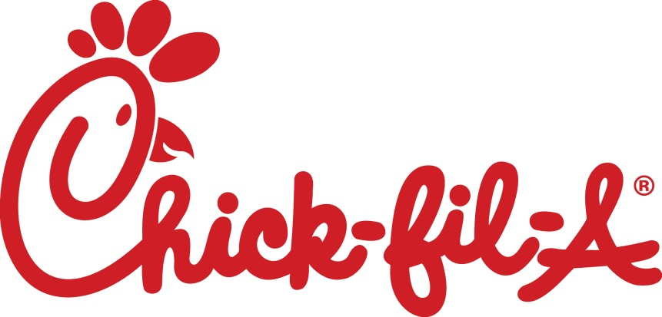
_____________________________________________________________________________
_____________________________________________________________________________
_____________________________________________________________________________
_____________________________________________________________________________
_____________________________________________________________________________
_____________________________________________________________________________
_____________________________________________________________________________

Exercise 4 – Participant Worksheet

Getting Your Message Out to Consumers

Overview: The purpose of this exercise is for you to begin to develop a marketing idea appropriate for the three media channels discussed. While completion of a fully developed idea will not be possible due to time constraints, hopefully you will begin to see that you capable of utilizing these channels and developing a personalized idea for your company.
Instructions: You will be divided into three groups. Using the easel pad and markers provided, work as a group to develop a basic advertisement using your assigned media channel. Please do not worry about artistic capability or fully developing your advertisement. After developing your advertisement, each group will share their plan with all participants who can then offer feedback.
Group TV
Using words and pictures develop a message and outline a possible TV ad that will be used to market local tomatoes at a regional farmers’ market. You can use any technique you wish including a storyboard similar to those of a comic book to help depict your idea for the ad’s story. If possible, add ideas about what type of broadcast you might want to use for your commercial.
Group Print
Using words and pictures develop a message and outline a possible print ad that will be used to market local tomatoes at a regional farmers’ market. Please include some value-added aspect for the consumer to encourage potential customers keep the ad and follow up on its use.
Group Website
Using words and pictures develop a message and outline a possible website that could be used to market local tomatoes at a regional farmers’ market. You can use any technique you wish to depict the information you wish to make available on the website.

Evaluation for Module 4

For the following statements, please answer by circling a number where 1=strongly disagree, 2=disagree, 3=neither agree nor disagree, 4= agree, and 5=strongly agree.
 |  | Before Workshop |  | After Workshop
a. I can describe the advantages of different media channels. |  | 1 2 3 4 5 N/A |  | 1 2 3 4 5 N/A
b. I am aware of pre-existing branding programs. |  | 1 2 3 4 5 N/A |  | 1 2 3 4 5 N/A
c. I know the steps to creating a personalized brand. |  | 1 2 3 4 5 N/A |  | 1 2 3 4 5 N/A
d. I can identify the characteristics of effective marketing strategies. |  | 1 2 3 4 5 N/A |  | 1 2 3 4 5 N/A
e. I can choose the most effective media channel for my message. |  | 1 2 3 4 5 N/A |  | 1 2 3 4 5 N/A
What are the three most important things you feel you have learned in this module?

What have you learned from this module that you plan to implement in the next year?

The amount of time spent on this module was: (Please circle one) | Too Short |  | Just Right | Too Long
The amount of material covered in this module was: (Please circle one) | Too Little |  | Just Right | Too Much

